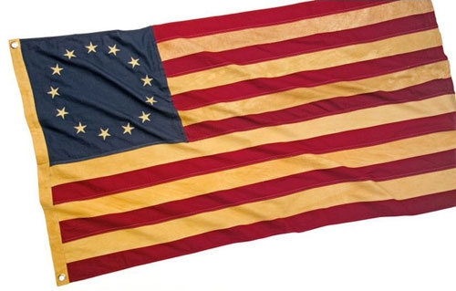
America’s First Veterans
© 2010
by
John W. Cowart

After the Revolutionary War the Continential Army required men mustering out to chop two cords of firewood for the army’s use.
In order to draw their final pay or to qualify for military pensions America’s first veterans also had to write or dictate statements detailing their activities during the War For Independence. These statements of service were stored in the National Archives. Besides those statements, some veterans wrote books about their war experiences.
Using such sources, I have compiled a few of these first-hand accounts for this article.
—John Cowart
America's first veterans virtually all volunteered. They enlisted in the Continental Army for a variety of reasons.
John Adlum, who became a corporal in General Washington's army, spoke about patriotic enthusiasum:
“I was living with ray Father at Yorktown... when I volunteered to go with the Militia... Independence was declared on the Fourth day of July 1776 and on the evening of the sixth... The Honorable James Smith...one of the signers of the said Declaration...arrived.
“On the Morning of the seventh,..the four companies of the town militia was paraded….
“When the Declaration of Independence was read... Mr. Smith made a short concluding speech and then threw up his hat and hurrahed for liberty and independence.... Others attending followed (his) example.
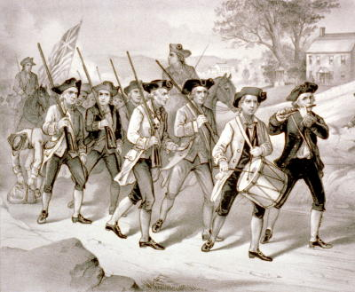
“There was then a proposition of 'Who will go to camp?” when I believe everyone on parade without exception volunteered to go, and of which I was one,” John Adlum wrote.
Jehu Grant, a Negro slave, explained his reasons for joining the Revolutionary Army saying:
“I was then grown to Manhood, in the full vigor and strength of life and had heard much about the cruel and arbitrary things done by the British. Their ships lay within a few miles of my master's house...and I suffered much from fear that I should be sent aboard a ship of War.
“This I disliked.
“But when I saw liberty poles and the people all engaged for the support of Freedom, I could not but like and be pleased with such thing (God Forgive me if I sinned in so feeling.) And living on the borders of Rhode Island, where whole companies of colored people enlisted, it added to my fears and dread of being sold to the British. These considerations induced me to enlist into the American Army....”
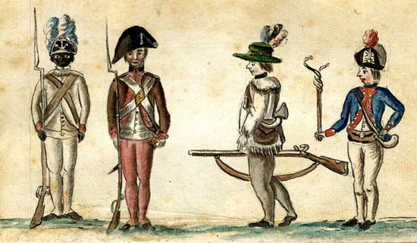Jehu earned his freedom from the slave owner after the revolution.
A white slave, Daniel Korris, also joined. the Continental Army to escape a Tory master. His father had sold him as a slave to pay the family's boat passage from Scotland. At the time Morris enlisted in Philadelphia, the American Army was requisitioning all horses and wagons in the area.
Daniel Korris said, “I told my Master, who was a Quaker, of it. He said, ‘Does Thee not wish that They would come and press my horse and wagon and press Thee to drive it?’
“I told him I did. I had a whip in my hand which he took from me and gave me several lashes with it and said, ‘Thee Scotch Rebel, Thou was a rebel in Thine own country and now Thou has come here to rebel’.
“So I determined to leave him which I did in about a week from the time he struck me, and then I enlisted in Colonel Preston's Artillery”.
Daniel was recaptured by his master and escaped twice before he could finally remain in the army—but his Quaker master collected all his military pay.
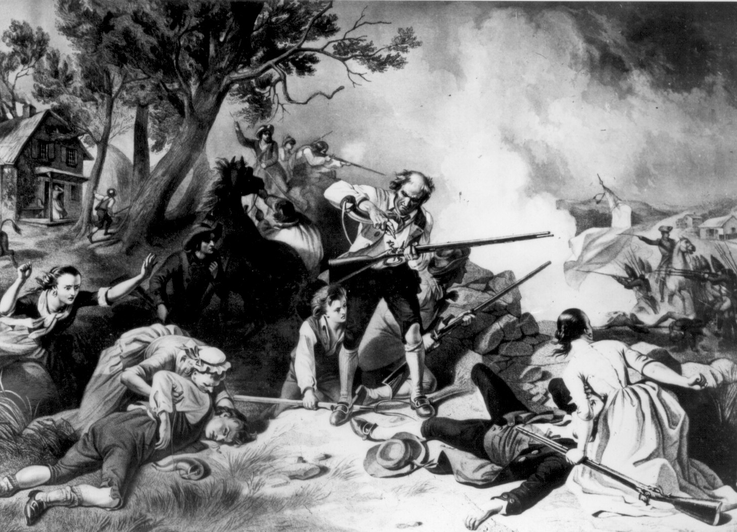
In 1779 Samuel Shelley joined the Army thinking the war would be over soon.
He wrote, “Colonel Dickinson...said to me, ‘Sam, join us for nine months and then maybe the war will be over.’
“So I joined them...the next day...They gave me a musket and bayonet, a knapsack and canteen, a cartridge box and an old rug to sleep on. They then began to learn me the exercise, and they found me a green hand, for I had never fired off a gun.”
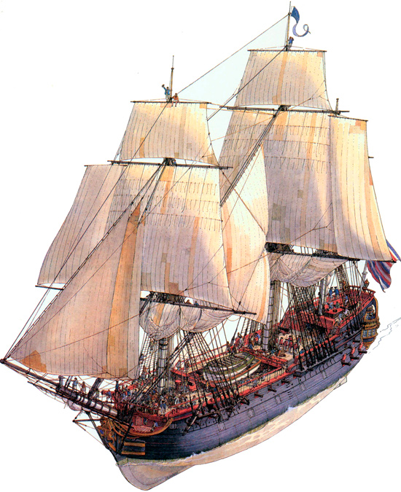
Of course not every patriot liked the Revolutionary Army; some joined the Navy.
John Ingersoll served in the New Jersey Militia from 1776 til 1778 and then switched. “I began to be wearied,” he said, “with the Marchings and counter-marchings which I was continually subject to, and being informed that if I entered on board a privateer... it would serve the same purpose, i.e. clear myself from any other military duty, accordingly I entered on board the schooner Enterprize.”
This proved to be a sad move for Ingersoll who was captured by the enemy and confined to a prison ship. The British anchored old hulks offshore for use as prisonor of war camps.
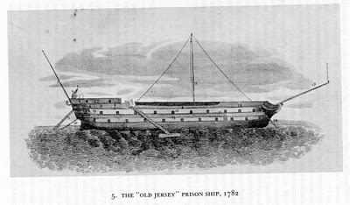
As a POW aboard such a prison ship, John Ingersoll wrote,”The water was bad and the provisions worse. Our allowance was a half pound of Mutton per day, but, to our surprise, when the Mutton came on board it was only the heads of sheep with the horns and wool thereon....Thus we kept soul and body together.”
POWs Aboard A Prison Hulk
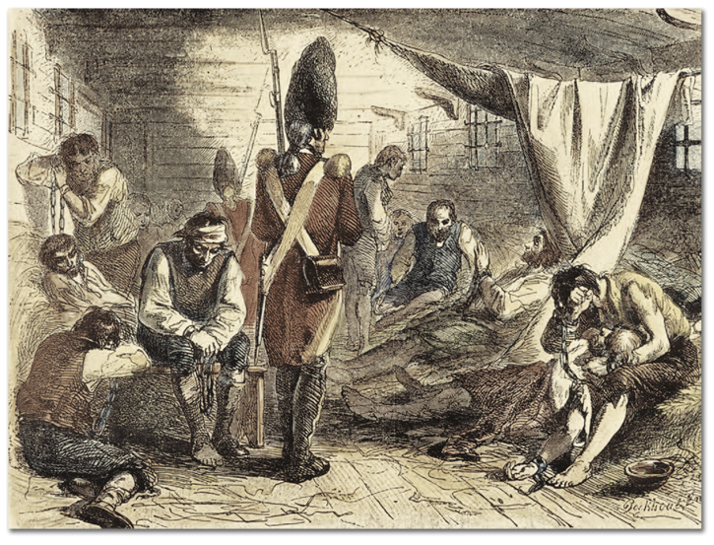
Foraging for something—anything—to eat occupied much of the colonial minuteman's time.
During the American Army’s march on Quebec, Private Richard Vining said, “...Our Company was obliged to kill a dog and eat it for our breakfast, and in the course of that day I killed an owl and two of my messmates and myself fared in repast.... Next day started and I was taken sick...”
Small wonder.
The early American soldier battled on many fronts; while he was away from home his Tory neighbors, sympathetic to the British cause, were likely to persecute his family, fill in his well, chop down his fruit trees, burn his crops, and steal his livestock.
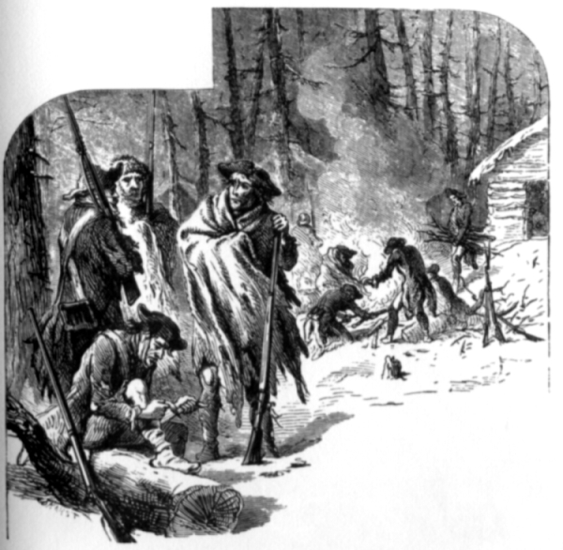
The enemy stirred up Indian tribes to attack American holdings. Disease took a heavy toll in soldier's lives. During the seige of Quebec the enemy defenders sent women infected with smallpox out of the city into the American lines hoping to introduce the disease into our camp.
Weather also tormented the soldiers.
Samuel Shelley tells of the thaw of the hard winter of 1779-80:
“We were encamped very near a large swamp where there was firewood to be had. As the snow sunk away, it left the stumps of trees standing ten or twelve feet high.”

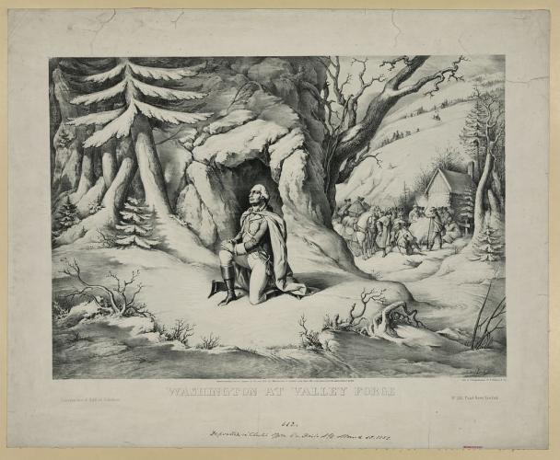

One of the great traditional pictures from the Revolutionary War shows General Washington praying in the snow at Valley Forge.

Lack of ammunition and arms also plagued the Americans.
William Lloyd, Calvaryman, charged into a retreating British force near Allentown, Pennsylvania hoping to capture weapons.
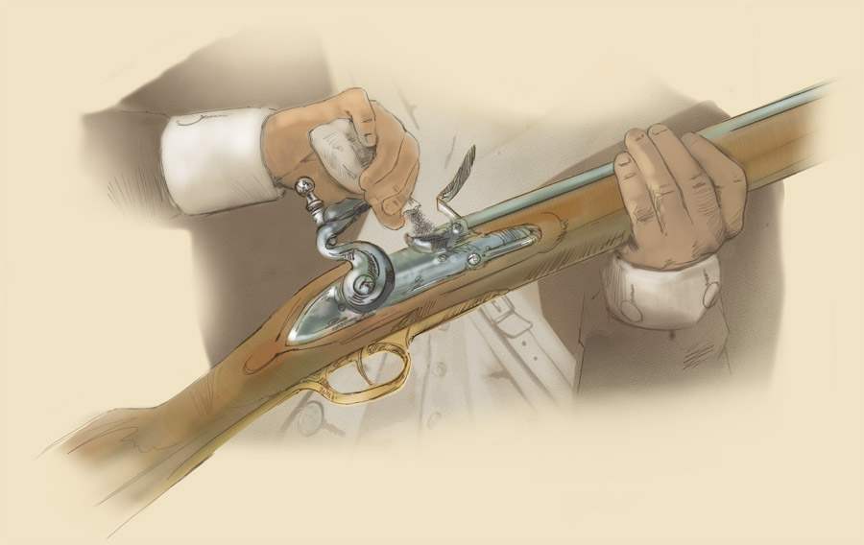
He wrote, “The enemy then retreated precipitately throwing away many of their guns. I was, I believe, the foremost in following, got as many of their guns as I could conveniently manage on my horse, with their bayonets fixed upon them. Gave them to the soldiers as they stood in rank. They threw away their French pieces, perferring the British.”
Joseph Plumb Martin tells of defending a fort in Billings port, New Jersey:
“We had a thirty-two pound cannon in the fort, but had not a single shot for it. The British also had one in their battery..,. It was fixed as to rake the Parade (Ground) in front of the barracks, the only place we could pass up and down the fort. The Artillary Officers offered a gill of rum for each shot fired from that piece.... I have seen from twenty to fifty men standing on the parade waiting with impatience the coming of the shot, which would often be seized before its motion had fully ceased and conveyed off to our gun to be sent back again to its former owners.”
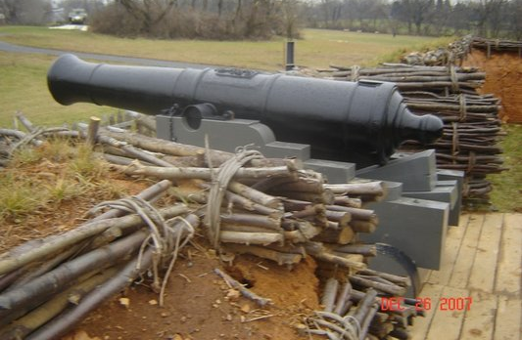
Martin tells of the pounding the American fort took:
“When the firing had in some measure subsided and I could look around me, I found the fort exhibited a picture of desolation. The whole area of the fort was as completely ploughed as a field. The buildings.were hanging in broken fragments, and all the guns dismounted, and how many of the garrison sent to the world of spirits, I know not.
“If ever destruction was complete, it was here.”.
The Americans surrendered this fort, but they won other battles.
Every battle was an uphill battle.
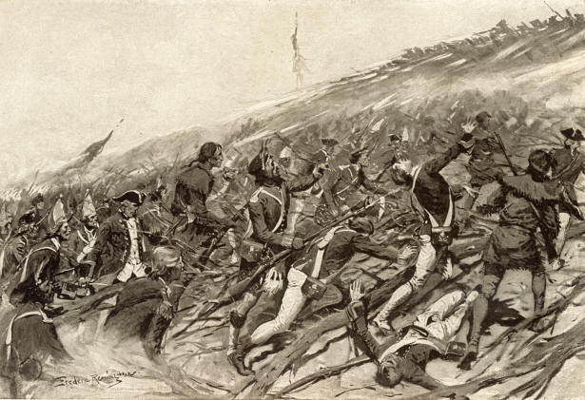
In another battle, William Patchin, a foot soldier, tells of fighting a horseman:
“I was in the right part of the line and early in the engagement one of the eneny, a strong and good-looking fellow, rode up, spurred up to me and said, 'Get back you damned Rebel.'
“I said to him,'Keep your place’.
“He then made a pass at me, cut through my cap and wounded me slightly on the forehead and the scar still remains. I then made a pass at him and so used my sword that he fell from his horse, and, although I do not know the final result, I have no doubt he never afterwards raised the battle-cry of King George and his herd of cattle-stealing Tories.”
Joheph Martin confronted British horsemen on the other side of a wide creek:
“When they saw me they hallooed to me calling me ‘a white-livered son of a b__h’...
“We then became sociable; they advised me to come over to their side and they would give me roast turkey. I told them that they must wait til we left the coast clear err they could get into the country to steal them...
“They then inquired what execution some cannon had done, just before fired from their island, if they had not killed and wounded some of our men? And if we did not want help, as our surgeons were a pack of ignoramuses. I told them in reply that they had done no other execution with their guns than wounding a dog (which was the case), and as they and their surgeons were of the same species of animal, I supposed the poor wounded dog would account it a particular favor to have some of his own kind to assist him.
“I saw the flash of a gun. I instinctively dropped as quick as a loon could dive when the ball passed directly over me... I immediately rose up and slapping my backsides to them slowly moved off.”
In addition to the dangers of being shot, Martin tells of other hardships:
“Almost everyone has heard of the soldiers of the Revolution being tracked by the blood of their feet on the frozen ground. This is literally true, and the thousandth part of their sufferings has not, nor ever will be told...
“Fighting the enemy is the great scarecrow to people unaquainted With the duties of our army...But, believe me, for I tell a solemn truth, that I have felt more anxiety, undergone more fatigue.nor.suffered more in everyway in performing one of those tedious marches than ever I did in fighting the hottest battle.
“It is fatiguing, almost beyond belief,...to be obliged to march twenty-four or forty-eight hours as very many times I have had to. Night and day without rest or sleep.. .when I was wet to the skin.
“I have often been so beat out with long and tedious marching that I have fallen asleep while walking and not been sensible of it till I have jostled against someone in the same situation…
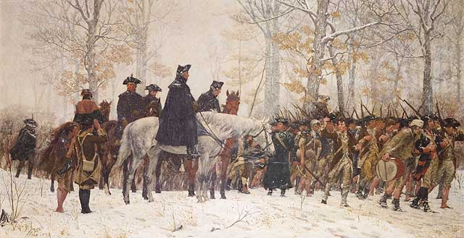
“When permitted to stop and have the superlative happiness to roll myself in my blanket and drop down on the ground in the bushes, briars, thorns, or this ties... O.¹ How exhilarating,” Martin said.
Hunger, disease, battle, marches, all tormented America's first veterans for the eight years of the Revolution and toward the end of the war one soldier complained, “The greatest inconvenience we felt was the want of good water, there being none near our camp (at Yorktown) but nasty frog ponds where all the horses in the beighborhood were watered and we were forced to wade through the water in the skirts of the ponds, thick with mud and filth, to get at water in any wise fit for use—and that full of frogs.”
But the fall of Yorktown marked the end of the war.
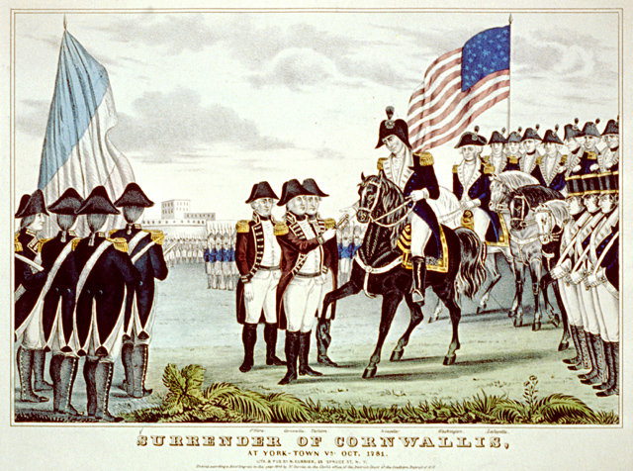
A wagoneer, William Burnett told how he learned the news:
“While I was guarding some prisoners, an officer rode up (to Prince Edward Courthouse) on a panting horse with a cocked hat on and ordered up guards to form a square with the prisoners inside, and then the news of the surrender of Lord Cornwallis was read and I remembers that the officer threw his cocked hat up in the air and almost every American present done the same and the words 'America is ours' seemed to almost rend the air, such was the joy at that time.”
America's first veterans had won the War for Independence and were ready for their discharges. The Army allowed most of the men to keep their muskets, balls and powder, but the Army also insisted that each man chop two cords of firewood for military use before going home.
Joseph Martin describes the day of his release:
“After the full eight years of service, anticipation of the happiness I should experience upon such a day as this was not realized…
“There was as much sorrow as joy transfused on the occasion. We had lived together as a family of brothers for several years... had shared with each other the hardships, dangers and sufferings incident to a soldier's life; had sympathized with each other in trouble and sickness;... bearing each other's burdens...
“And now we were to be, the greater part of us, parted forever; as unconditionally separated as though the grave lay between us... I question if there was a corps in the Army that parted with more regret than ours...
“Ah. It was a serious time.”
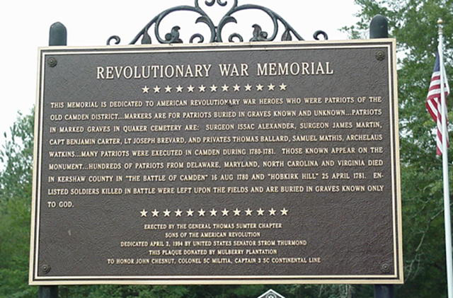
END
Thank you for visiting www.cowart.info
I welcome your comments at my blog at http://www.cowart.info/blog/
You can E-mail me at cowart.johnw@gmail.com
You can view my published works at www.bluefishbooks.info

Bluefish Books

Cowart Communications
Jacksonville, Florida
www.bluefishbooks.info

