MAY MEETING
M.E.D. NEIGHBORHOOD WATCH
For Everyone Living In the 2800 & 2900 Blocks Of Myra, Ernest & Dellwood Streets.
7:00 p.m., Monday, May 12th
at
The Home of Judy Staley, 2908 Dellwood Street

Special Speaker Jennifer Stagg, Program Manager of Jacksonville’s Community Emergency Response Teams, will introduce us to disaster survival skills.
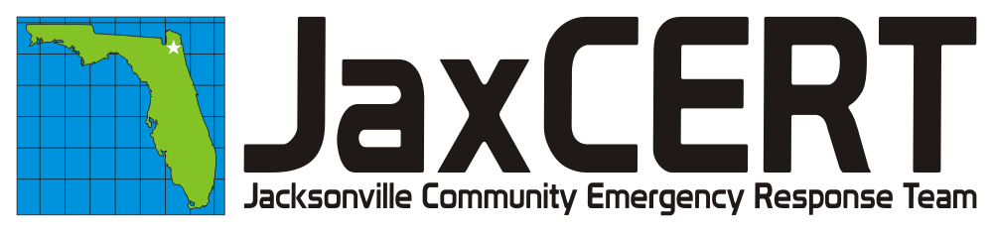
Remember Hurricane Katrina?
Other disasters you’ve seen on tv?
When a wide-spread disaster such as a hurricane, terrorist attack, or tornado strikes, Jacksonville officials say it may take several days before emergency services can reach local neighborhoods.

Do you know how to stay alive and rescue your family and your neighbors before outside help comes?
JaxCERT training provides residents basic disaster-response skills to address the urgent needs of their own families and their neighbors until professional first responders and emergency personnel arrive.
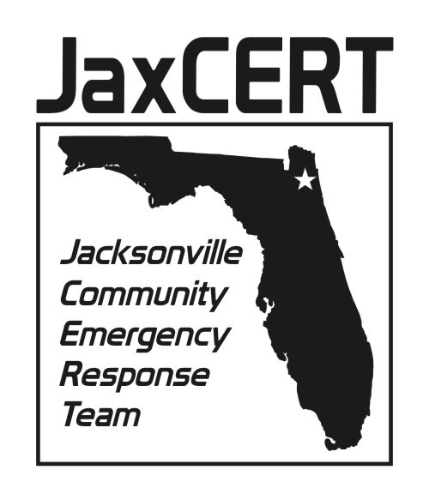

Please come to the May MED Watch meeting with your own ideas and suggestions for improving life in our neighborhood. We’ll listen. At our meetings everyone gets a chance to speak.

